**LOOPS AND POINTERS**

**ASSIGNMENT-1**

Program-1:

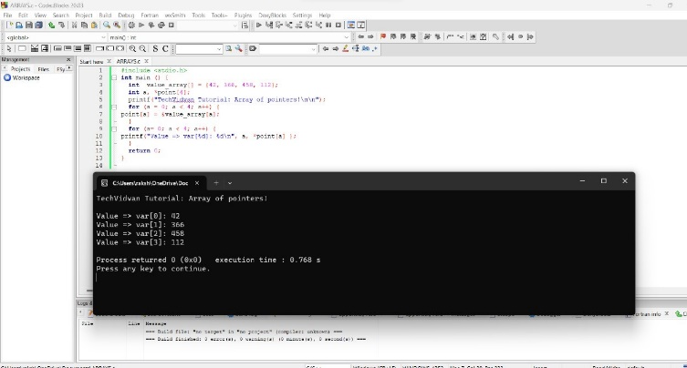

Program-2:

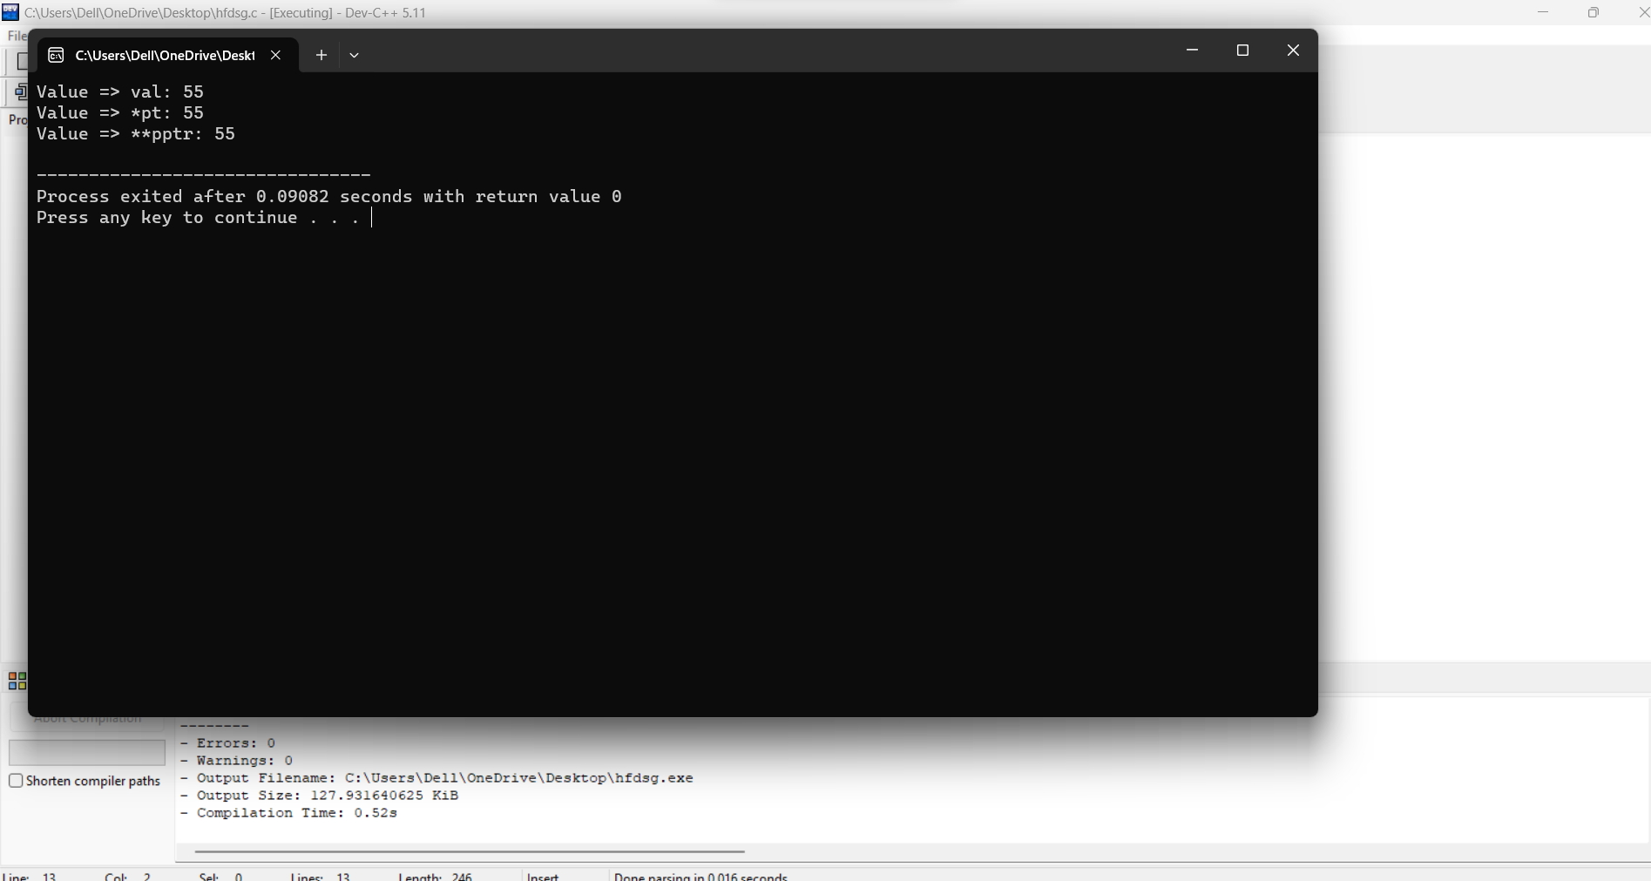

Program-3:

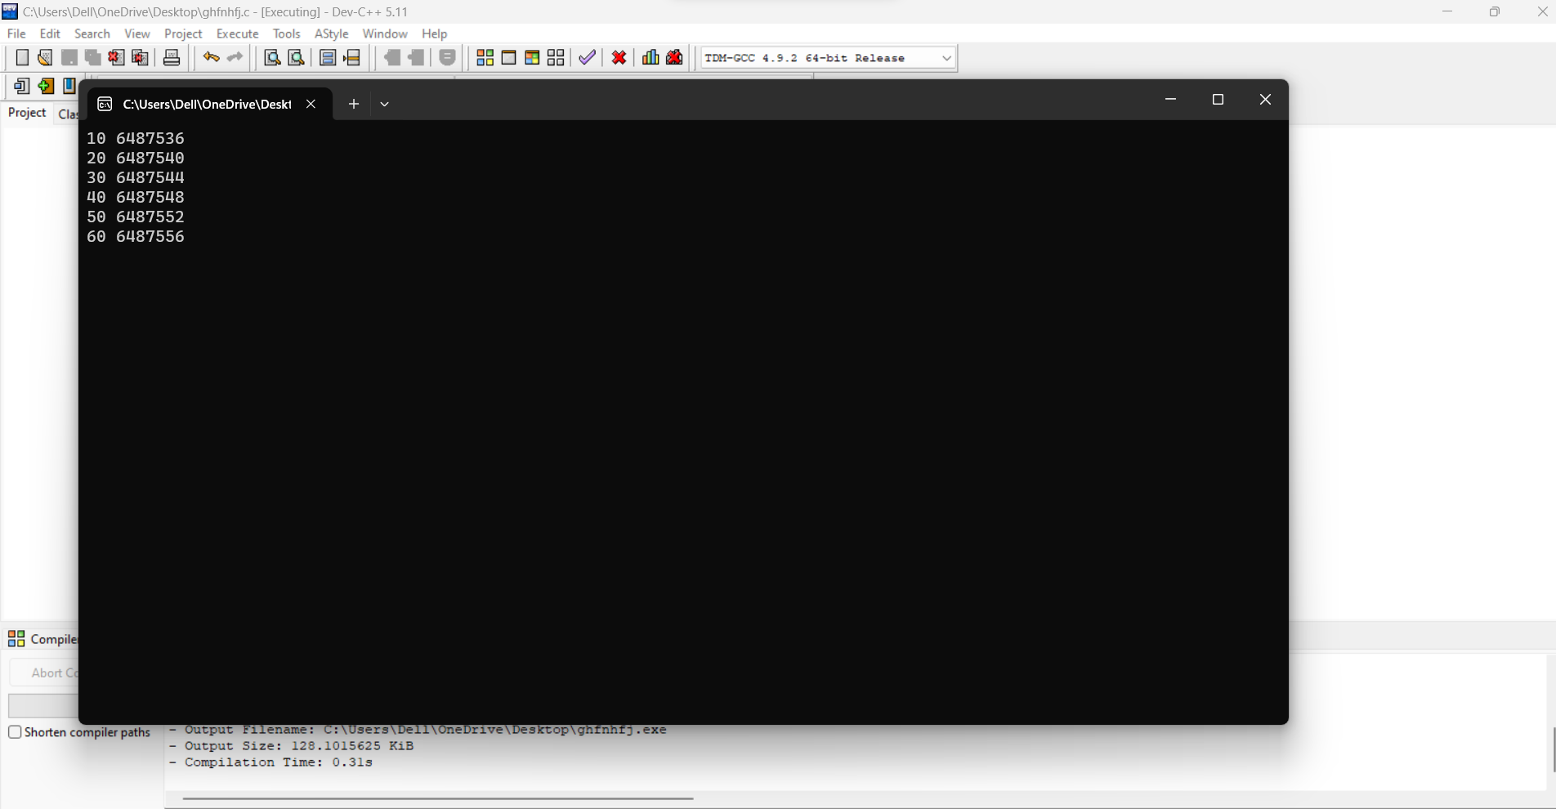

Program-4:

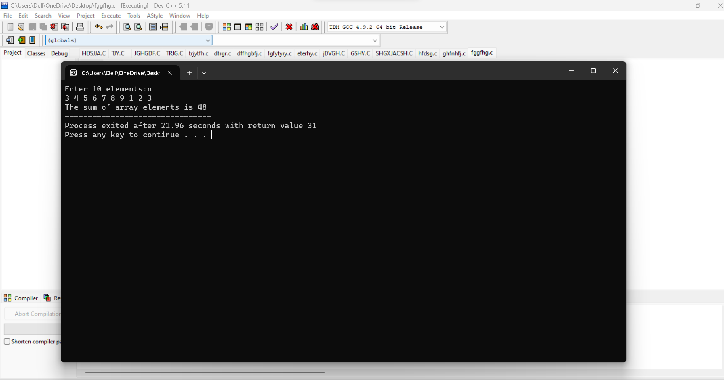

Program-5:

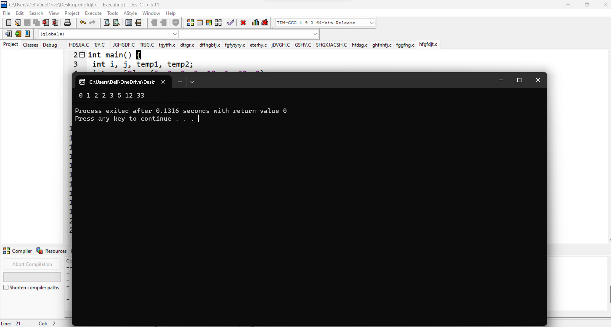

Program-6:

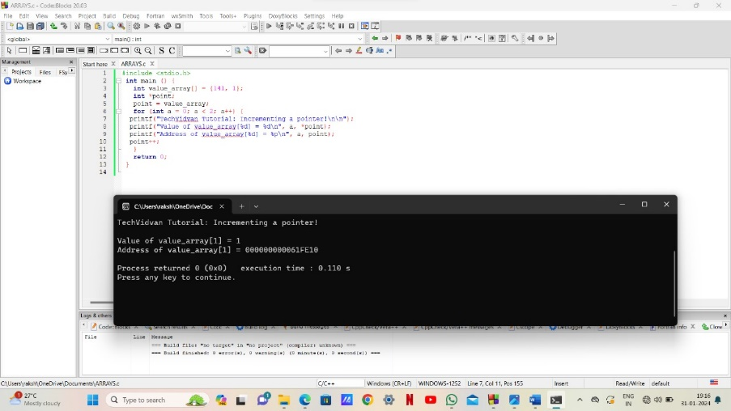

. **QUESTION(1)**

**Struct node**

**{**

**int i;**

**float j;**

**};**

**struct node *s[10];**

**The above C declaration defines**

**GATE CSE 2000**

**1. An array, each element of which is pointer to a structure of type node**

**2. A structure of 2 fields, each field being a pointer to an array of 10 elements**

**3. A structure of 3 fields: an integer, a float, and an array of 10 elements**

**4. An array, each element of which is a structure of type node**

**SOLUTION:**

The above C Declaration gives an array of 10 pointers to a structure [node] which contains integer[i] and float number[j]

HENCE, OPTION[1] IS CORRECT

**. QUESTION(2)**

**Assume that objects of the type short, float and long occupy 2 bytes, 4 bytes and 8 bytes,**

**respectively. The memory requirement for variable t, ignoring alignment**

**GATE CSE 2000**

**struct {**

**short s [5];**

**union {**

**float y;**

**long z;**

**}u;**

**} t;**

**1. 22 bytes**

**2. 18 bytes**

**3. 14 bytes**

**4. 10 bytes**

**SOLUTION:**

To determine the memory requirement for variable t, ignoring alignment

Variable t requires memory of 10bytes from the short s[5] as short data type occupy of 2 bytes

HENCE, float and long occupies 4,8 bytes respectively

The union takes size of largest member which is 8bytes

THEREFORE, total memory requirement is 10+8=18bytes

HENCE,OPTION[2] IS CORRECT

.**QUESTION(3)**

**What does the given program print?**

**char c[ ] = “GATE2011”**

**char *p = c;**

**printf (“%s”, p + p[3] – p[1]);**

**GATE CSE 2011**

**1. GATE 2011**

**2. 2011**

**3. E2011**

**4.011**

**SOLUTION:**

GATE2011

P[3]-E

P[1]-A

P+P[3]-P[1] is equivalent to P+E-A

The ASCII difference between E and A – [ 69-65]= 4 POSITIONS

Therefore, pointer P moves forward 4 positions “GATE2011”

So, it prints “2011”

HENCE, OPTION[2] IS CORRECT

.**QUESTION[4]**

**The output of the following C program is__________**

**GATE CSE 2015 Set 1**

**void f1(int a, int b) {**

**int c;**

**c=a; a=b; b=c;**

**}**

**void f2(int *a, int *b) {**

**int c;**

**c=*a; *a=*b; *b=c;**

**}**

**int main(){**

**int a=4, b=5, c=6;**

**f1(a,b);**

**f2(&b, &c);**

**printf(“%d”,c-a-b);**

**}**

**SOLUTION:**

In main function the value of a is 4, and the value of b becomes 6 and c becomes 5

[5-4-6=-5]

HENCE THE OUTPUT WILL BE -5

.**QUESTION[5]**

**The following program prints ___________**

**#include < stdio.h >**

**void f (int *p, int *q) {**

**p = q;**

**\*p = 2;**

**}**

**int i = 0, j = 1;**

**int main ( ){**

**f(&i, &j);**

**printf (“%d %d \ n”, i, j);**

**return 0;**

**}**

**GATE CSE 2010**

**1. 2 2**

**2. 2 1**

**3. 0 1**

**4. 0 2**

**SOLUTION:**

As we know i=0 and j=1

And this I value will store in *p and j value will store in *q

If we assume i=100 and j=200

In given program we know p=q so, p will also be 200

So *p=2

THEREFORE, i will be 0 and j will be 2

OUTPUT WILL BE 0,2

HENCE, OPTION[4] IS CORRECT

.**QUESTION[6]**

**The output of the following C program is**

**GATE CSE 2018**

**#include< stdio.h >**

**struct Ournode{**

**char x,y,z;**

**};**

**int main(){**

**struct Ournode p = {‘1’, ‘0’, ‘a’+2};**

**struct Ournode *q = &p;**

**printf (“%c, %c”, *((char*)q+1), *((char*)q+2));**

**return 0;**

**}**

**1. 0, c**

**2. 0, a+2**

**3. ‘0’, ‘a+2’**

**4. ‘0’,’c**

**SOLUTION:**

As we know p={1,0,a+2};

In *q the values of p will be stored

*((char*)q+1) will be 0 and *((char*)q+2)) will be a+2

HENCE, OPTION[2] IS CORRECT

.**QUESTION[7]**

**The output of the following C program is**

**#include < stdio.h >**

**void mystery(int *ptra, int *ptrb) {**

**int *temp;**

**temp = ptrb;**

**ptrb = ptra;**

**ptra = temp;**

**}**

**int main() {**

**int a=2016, b=0, c=4, d=42;**

**mystery(&a, &b);**

**if (a < c)**

**mystery(&c, &a);**

**mystery(&a, &d);**

**printf(“%d\n”, a);**

**}**

**SOLUTION:**

As we know a=2016,b=0,c=4,d=42

If we assume p=100 and q=200

Here only addresses will be swaped and the value of a,b,c,d will be same

HENCE THE OUTPUT WILL BE 2016

.**QUESTION[8]**

**The output of the following C program is**

**#include < stdio.h >**

**int main () {**

**int arr [] = {1,2,3,4,5,6,7,8,9,0,1,2,5}, *ip = arr+4;**

**printf (“%d\n”, ip[1]);**

**return 0;**

**}**

**SOLUTION:**

As we know int arr[]={1,2,3,4,5,6,7,8,9,0,1,2,5}

*ip=arr+4 means it will move 4 steps forward and take those as arr

Therefore the int arr[]={5,6,7,8,9,0,1,2,5}

Hence ip[1]=6

HENCE, THE OUTPUT WILL BE 6

**.QUESTION[9]**

**Consider the following C function**

**GATE CSE 2004**

**void swap (int a, int b)**

**{**

**int temp;**

**temp = a;**

**a = b;**

**b = temp;**

**}**

**In order to exchange the values of two variables x and y**

**1. call swap (x,y)**

**2. call swap (&x, &y)**

**3. swap (x, y) cannot be used as it does return any value**

**4. swap (x,y) cannot be used as the parameters are passed by value**

**SOLUTION:**

In order to exchange the values of two variables X and Y

We need to swap them with a addresses and it was know as call by reference

HENCE, OPTION[2] IS CORRECT

**THE END**